STANDARD FORMAT OF “LEHENGA DESCRIPTION”


For Online Selling Products
Design Name: HERITAGE
Product Colours NO.: A2
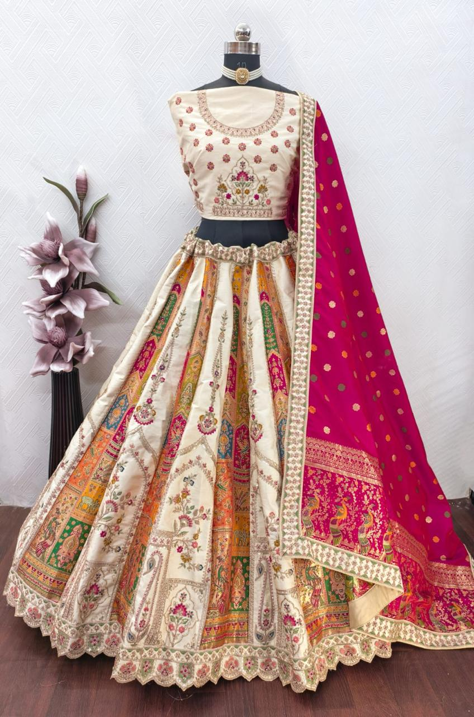
Particulars | Details
Lehenga Fabric | Satin + Rapier
Blouse Fabric | Satin
Dupatta Fabric | Rapier
Work Type | Jari, Stone & Sequence
Colour | Chiku
Pattern | Girlish Designer Lehenga
Stitching Type | Semi-Stitched (Can be customized up to 44")
Occasion | Wedding, Reception, Engagement & Festive Wear
Fit Type | Regular Fit
Care Instructions | Dry Clean Only
Package Contents | 1 Lehenga, 1 Blouse Piece, 1 Dupatta

KEY HIGHLIGHTS
- Satin & Rapier fabric for a rich and premium look
- Detailed Jari, Stone & Sequence work for an elegant festive finish
- Semi-stitched lehenga (44” size) for easy fitting and customization
- Includes matching satin blouse and rapier dupatta
- Available in vibrant colours: Green, Chiku, Mehendi, Purple, Gajari & Blue (as per stock availability)
- Ideal for reception, party wear, and festive occasions
- Regular-fit design ensures comfort during long hours
- Dry-clean-only garment to maintain shine and quality

